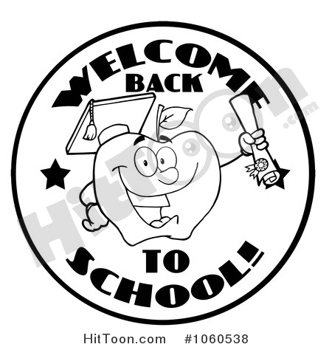

**Second Grader!**

Welcome to the second grade! Second grade can be a fun and exciting school year, but it is also a big change from first grade. The work can be challenging, but if you keep a good attitude, work hard and do your best, you will do fine. There are a few things we thought would be good for you to know for this school year.

**Conduct** In second grade, it is crucial that students are following directions and paying attention at all times. Second grade is following the school wide rules. Each teacher will be recording strikes for each class. Conduct sheets will go home daily and need to be initialed and returned each morning. Students are expected to come to school prepared, stay on task, complete all assignments (including homework) and be respectful. Below is a copy of the Behavior Plan for the Classroom.

|  |  |  |  |
| --- | --- | --- | --- |
| Personal Image result for paw print clip artAccountability | Accept Image result for paw print clip art  Respsonsibility | Work Image result for paw print clip art  Hard | Show Image result for paw print clip art  Respect |
| * Keep your hands and feet to yourself * Use an inside voice * Use your manners * Keep trying even when it’s hard * Follow rules * Take care of textbooks and materails | * Listen and follow directions the first time * Do your best! | * Complete work on time * Stay actively involved in the lesson * Once you sit down, remain seated | * Say nice things or nothing at all (please, thank you, excuse me, etc.) * Walk * Raise your hand if you have a question * Keep your hand and feet to yourself |

Paw Bucks are earned for displaying positive behavior and can be used for various things like Wildcat Den, Celebrations, and the store. Strikes are earned when behavior is not acceptable and rules are broken. Strikes result in point deducted from conduct grade, as well as other consequences- such as loss of recess time or activities.

**Signed Papers:** Students will bring home papers that were completed previously on a bi-weekly basis in blue folders . Please look over these papers with your child. Sign the back page of the folder and return the entire set to the teacher on the next school day.

**Homework** : Homework for the week is assigned at the beginning of the week. Assignments can also be found on the Canvas/Seesaw platform. Occasionally, projects may require some weekend work.

**Grading and Promotion Requirements**: Second Grade follows standard based grading. Students will receive a grade of 1-4. Receiving a 3 or 4 indicates mastery, 2 indicates progressing towards mastery, and 1 indicates the standard has not been met. For Kindergarten through 3rd Grades to meet promotion requirements, a student must master essential standards for Language Arts and essential standards for Mathematics as identified on the Richmond County Board of Education report card.

**Dress Code and Attendance:** Students are expected to follow the county dress code and attendance/tardy policies as outlined in the Code of Conduct handbook that was given out at registration.

**Transportation Changes:** If your child’s transportation changes, a note must be sent to the school. On a sheet of paper please include the following information: the date, student’s name, teacher’s name, the transportation change and the dates of the change, signature of parent and a local working telephone number. Contact will be made by the office to verify the changes. This must be done each and every time a change occurs.

**School Website:** Please visit our school website at <http://wforeman.rcboe.org>. Many resources are available here, including lunch calendars, teacher e-mail addresses, other contact information, PTO news, etc..

Thank you in advance for your support,

Second Grade Teachers: Ms. T. Jennings, Ms. T. Joyce, and Ms. S. Ratliff

*Learning Today…Leading Tomorrow*

*The Mission of the Richmond County School System is building a world-class school system through education, collaboration, and innovation.*

